MODULE 7 AND 8

- Try Test-Connection and nslookup commands for below websites:
www.google.com,www.facebook.com,www.amazon.com,www.github.com,www.cisco.com
Test -Connection:
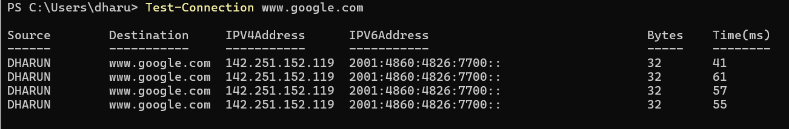
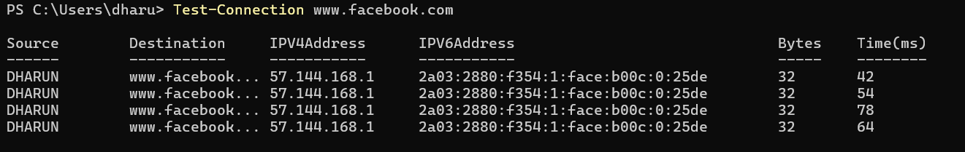
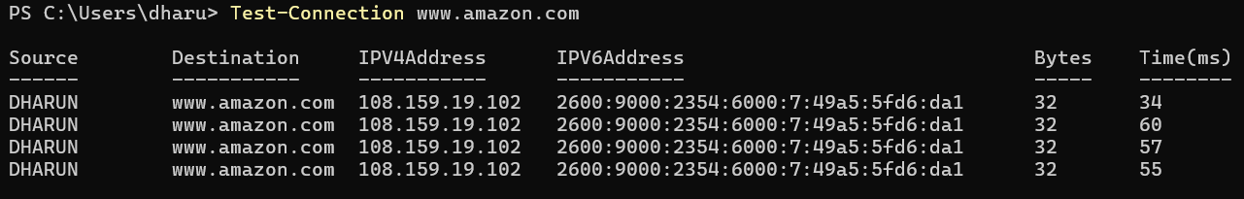
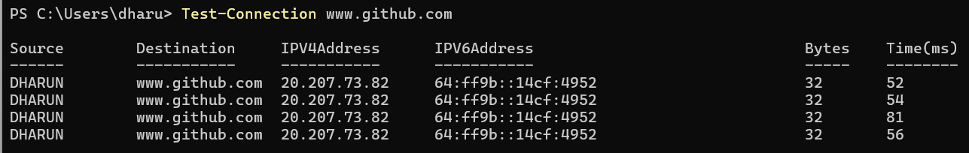
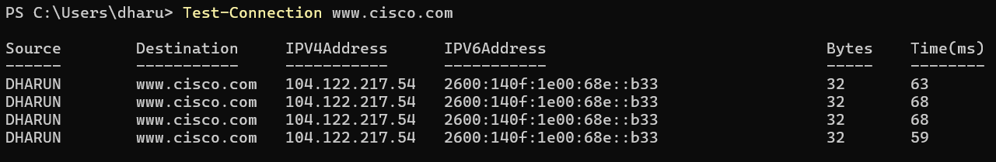

nslookup:

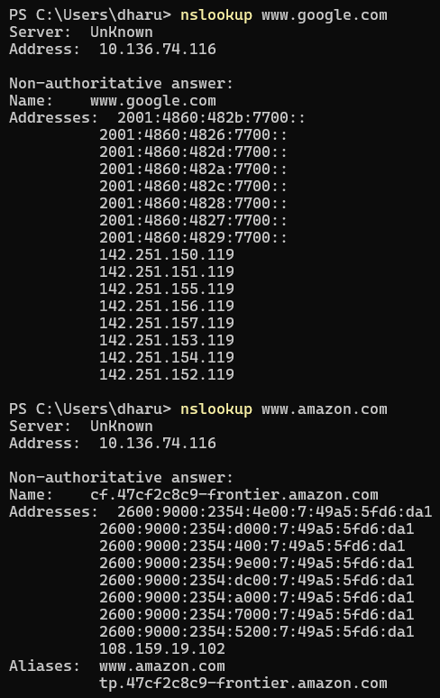

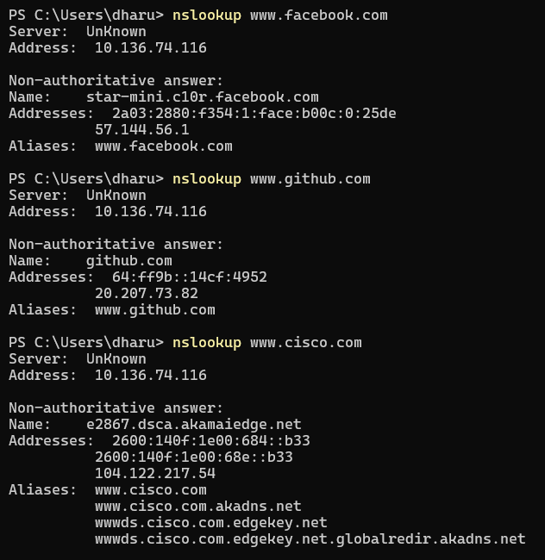

- Use Wireshark to capture and analyze DNS, TCP, UDP traffic and packet header, packet flow, options and flags.
DNS:
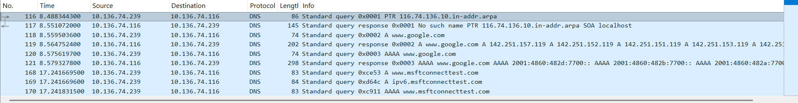

Dns query:
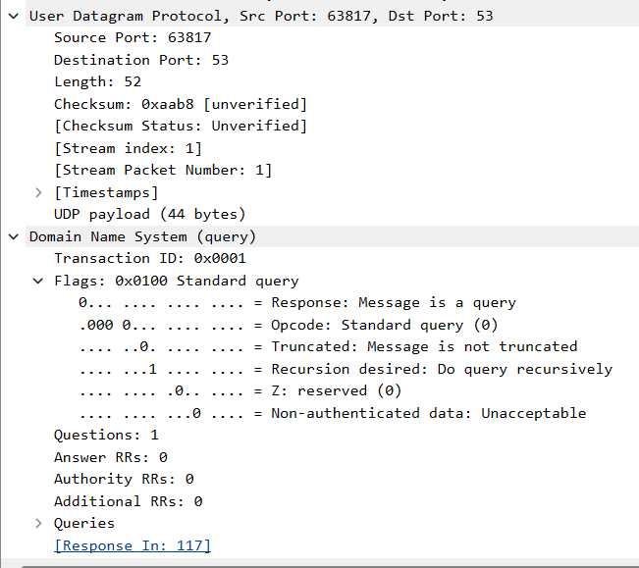
Dns response:
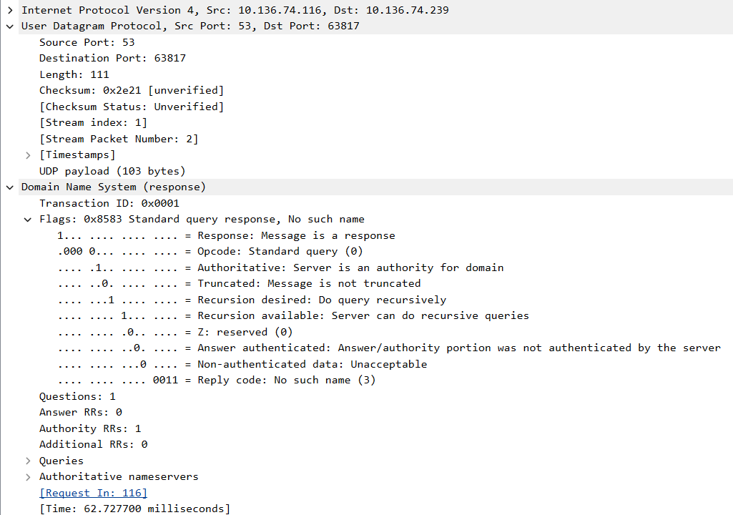
DNS packets were captured using Wireshark and analyzed.
The DNS query packet was sent from the client to the DNS server using UDP protocol with destination port 53.
The DNS response packet was received from the DNS server to the client from port 53.
The DNS query contained a standard query request with recursion desired.
The DNS response packet contained the reply code and server response information.
DNS uses UDP protocol and operates on port 53 to resolve domain names into IP addresses.
TCP:
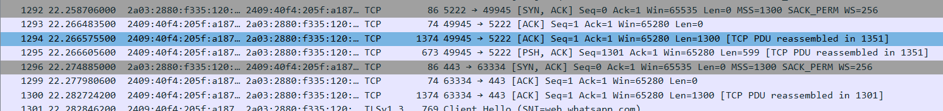
SYN:
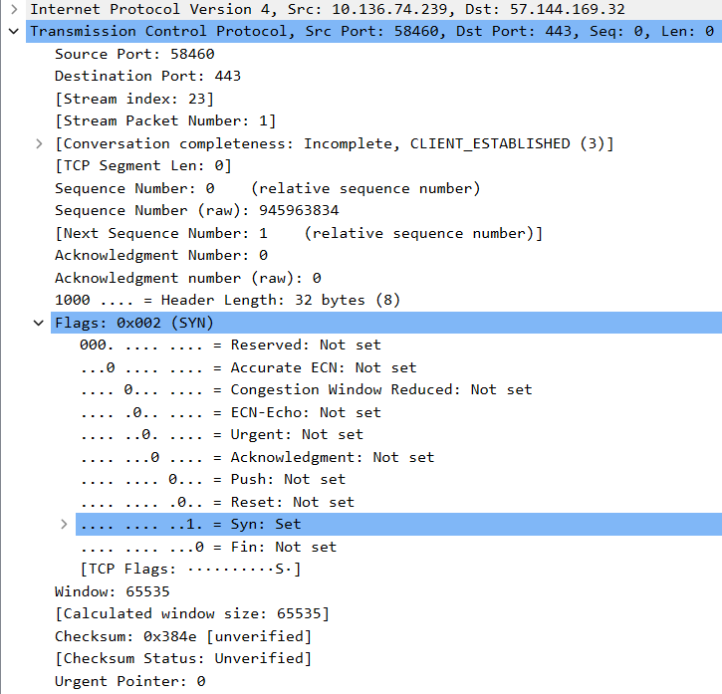

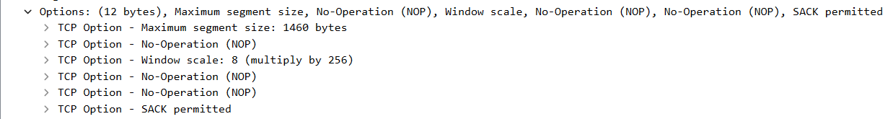
SYN ACK:
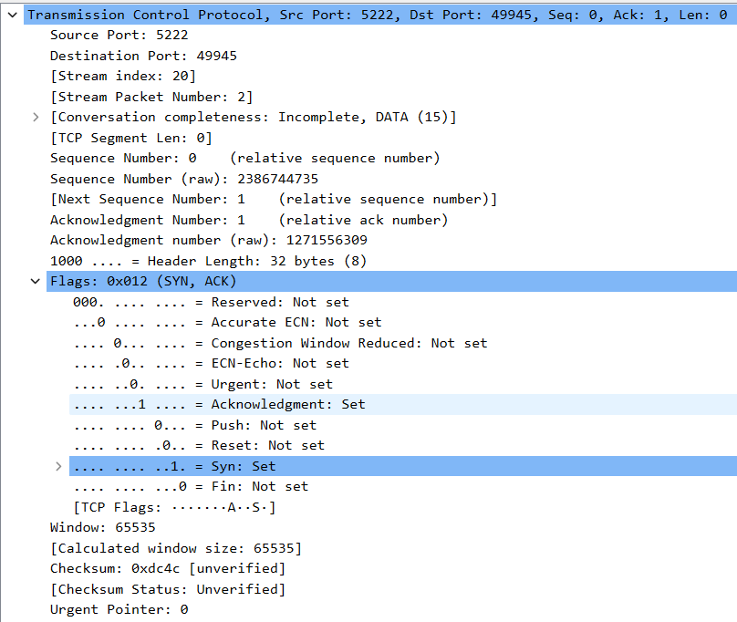
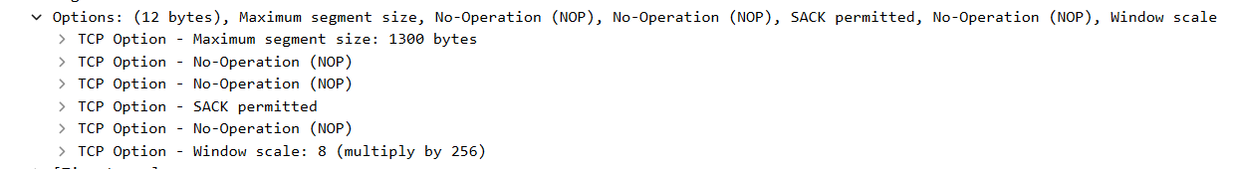

ACK:
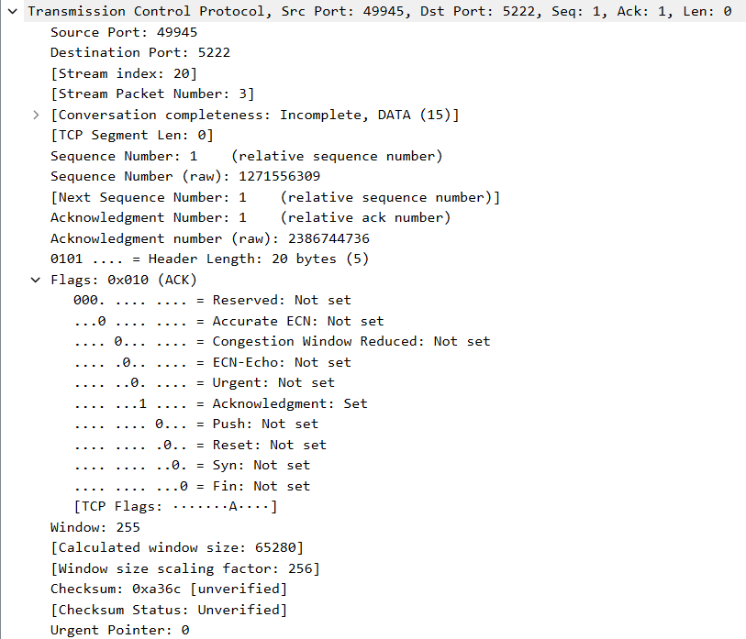

In the TCP capture, the three-way handshake was clearly observed. The client initiated the connection by sending a SYN packet to the server on port 443. The server responded with a SYN-ACK packet, acknowledging the connection request. The client then sent an ACK packet to complete the connection establishment. The TCP header fields such as sequence number, acknowledgement number, flags, window size and header length were analyzed. This confirms that TCP is a connection-oriented and reliable protocol.
Client Port → 58460 / 49945
Server Port → 443 (HTTPS)

UDP:
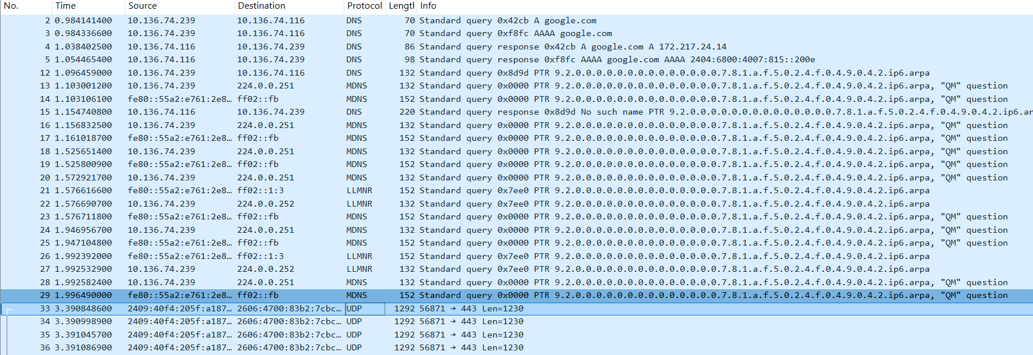

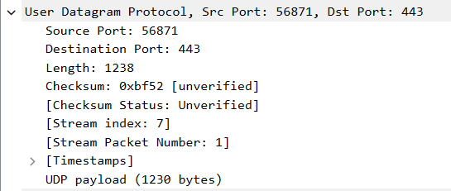
UDP traffic was captured using Wireshark. UDP is a connectionless protocol that sends data without establishing a connection. The UDP header contains source port, destination port, length and checksum fields. UDP is faster but does not provide reliability like TCP.
Source Port: 56871
Destination Port: 443
UDP Length field present
Checksum present
No sequence number
No acknowledgement
No flags like SYN/ACK
Connectionless communication
- Explore traceroute/tracert for different websites (e.g., google.com) and analyse the parameters in the output and explore different options for traceroute command.
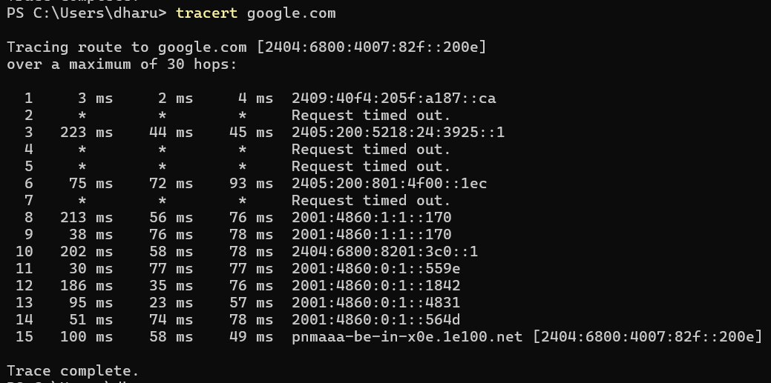
The tracert command showed that the packets traveled through 15 hops (routers) to reach the destination server. Each hop represents an intermediate router between the source and destination. The output also showed round trip time (RTT) values in milliseconds and some hops showed request timed out due to firewall or ICMP blocking. The final hop represents the destination server and the trace was completed successfully.
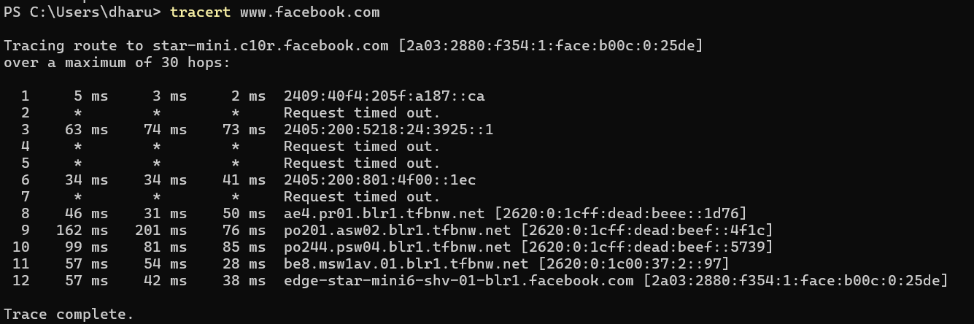

Do not resolve hostnames:
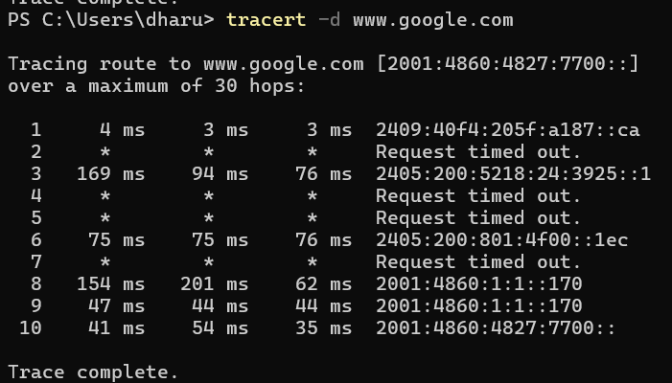
Maximum hops:
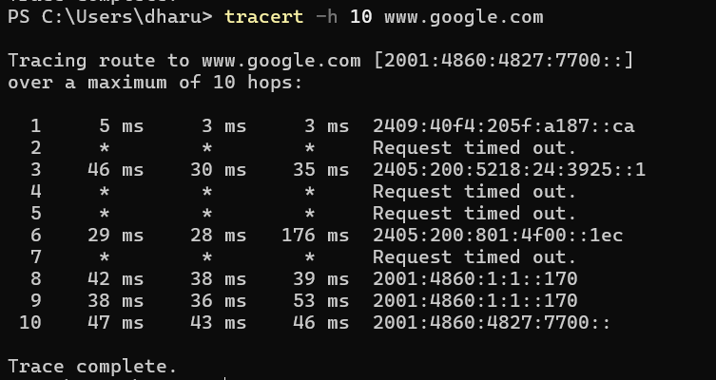
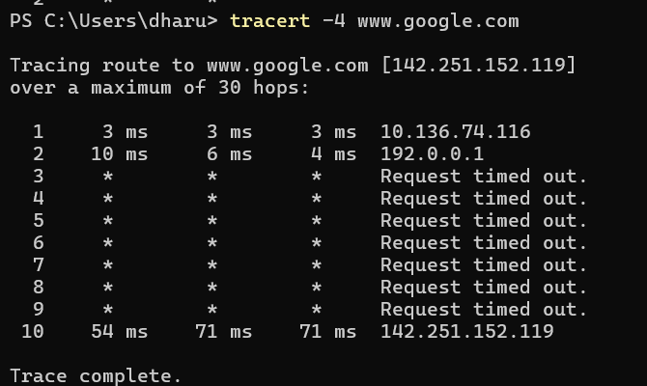

- Set up trunk ports between switches and try ping between different VLANs.
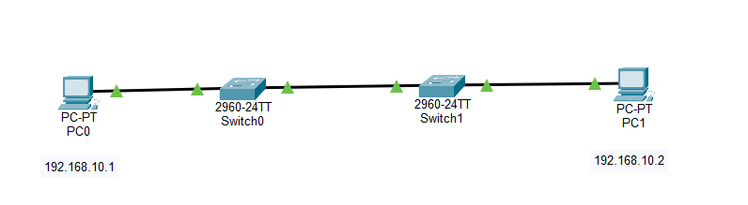
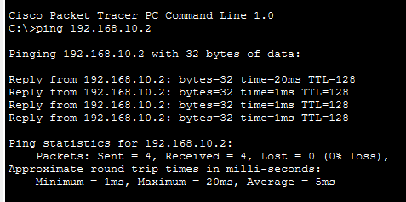
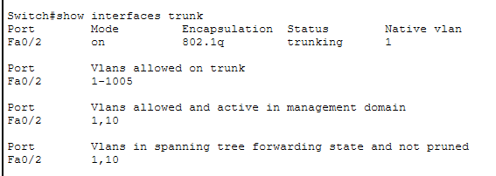
Two switches were connected using a trunk link. VLAN 10 was created and access ports were assigned to VLAN 10 on both switches. The trunk port was configured between switches using the switchport mode trunk command. The trunk port allowed VLAN traffic between switches. PCs connected in the same VLAN across different switches were able to communicate successfully using ping.

- Change the native VLAN on a trunk port. Test for VLAN mismatches and troubleshoot.

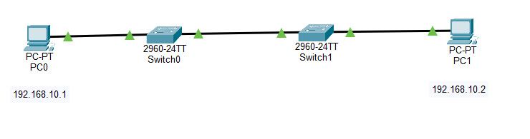
Changing native vlan and checking interfaces:
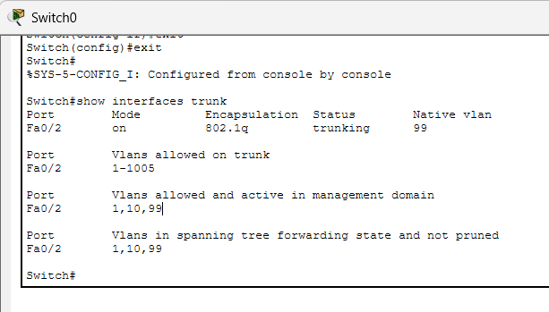
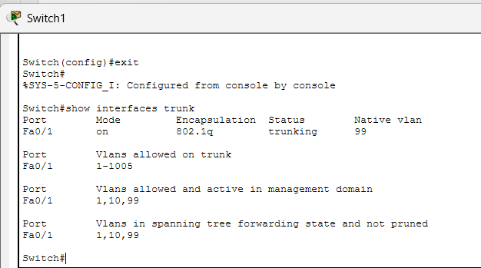

Vlan mismatching:
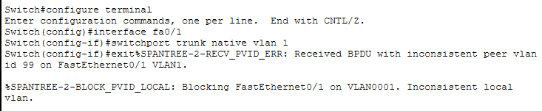
Troubleshooting vlan mismatch:
On both switches:
configure terminal
interface fa0/1
switchport trunk native vlan 99
exit
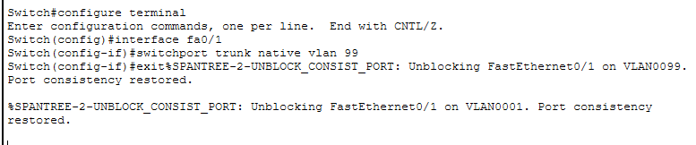
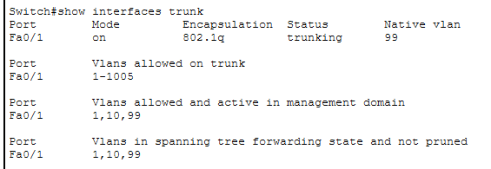
- Configure a management VLAN and assign an IP address for remote access. Test SSH or Telnet access to the switch.
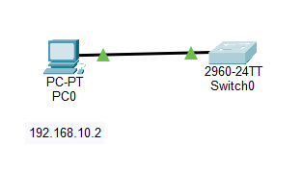
Creating VLAN 10:
enable
configure terminal
vlan 10
exit
Assigning Port to VLAN 10:
interface fa0/1
switchport mode access
switchport access vlan 10
exit
Configuring Management VLAN Interface (IP Address): Giving ip address to switch
interface vlan 10
ip address 192.168.10.1 255.255.255.0
no shutdown
exit
Configuring Default Gateway:
ip default-gateway 192.168.10.2
Telnet Configuration:
line vty 0 4
password cisco
login
exit
Configuring PC IP:
IP Address: 192.168.10.2
Subnet Mask: 255.255.255.0
Default Gateway: 192.168.10.1
Testing Telnet from PC:
telnet 192.168.10.1
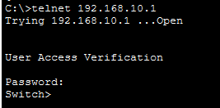
A management VLAN was created on the switch and an IP address was assigned to the VLAN interface. The PC was connected to the switch and configured in the same VLAN. Telnet access was configured using VTY lines and password authentication. The remote connection to the switch was tested using the Telnet command and the switch was successfully accessed remotely.
- You have a Cisco switch and a VoIP phone that needs to be placed in a voice VLAN (VLAN 20). The data for the PC should remain in a separate VLAN (VLAN 10).
Configure the switch port to support both voice and data traffic.
Creating VLANs:
enable
configure terminal
vlan 10
name DATA
exit
vlan 20
name VOICE
exit
Configuring port connected to ip phone:
interface fa0/1
switchport mode access
switchport access vlan 10
switchport voice vlan 20
exit
Verification:
show vlan brief
show interfaces fa0/1 switchport
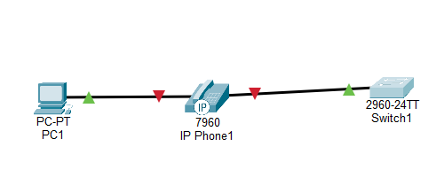
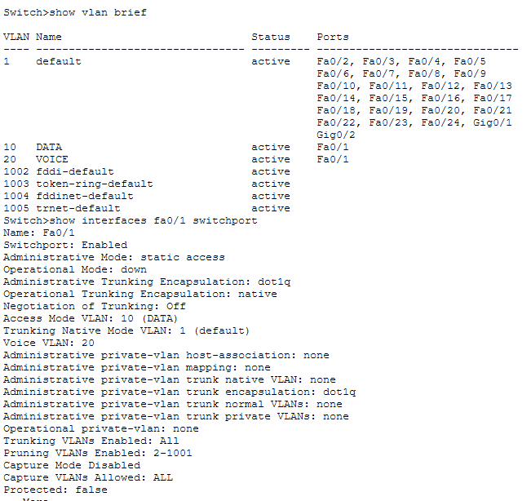
The VoIP phone was placed in Voice VLAN 20 and the PC was placed in Data VLAN 10. The switch port connected to the IP phone was configured using switchport access vlan 10 and switchport voice vlan 20 commands to support both voice and data traffic on the same port. This allows the switch port to carry both voice and data traffic simultaneously.
- You configured VLANs 10 and 20 on your switch and assigned ports to each VLAN.
However, devices in VLAN 10 cannot communicate with devices in VLAN 20.
Troubleshoot the issue. Try Inter-VLAN routing with Router

VLANs are separate networks, so a Layer 3 device (Router or Layer 3 Switch) is required for communication between VLANs.
Solution:
Configuring Inter-VLAN routing using Router-on-a-stick.

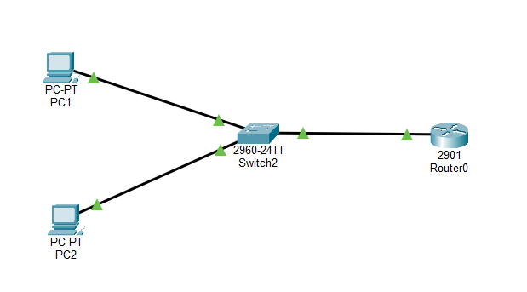
Creating vlans on switch :
enable
configure terminal
vlan 10
name DATA
exit
vlan 20
name VOICE
exit
Assign Switch Ports to VLANs:
interface fa0/1
switchport mode access
switchport access vlan 10
exit
interface fa0/2
switchport mode access
switchport access vlan 20
exit

Configure Trunk Port Between Switch and Router
interface fa0/3
switchport mode trunk
exit
Configure Router (Router-on-a-stick)
enable
configure terminal

interface g0/0
no shutdown
interface g0/0.10
encapsulation dot1Q 10
ip address 192.168.10.1 255.255.255.0
interface g0/0.20
encapsulation dot1Q 20
ip address 192.168.20.1 255.255.255.0
Configure PC IP Addresses
PC | IP Address | Gateway
PC VLAN 10 | 192.168.10.2 | 192.168.10.1
PC VLAN 20 | 192.168.20.2 | 192.168.20.1
Troubleshooting step by step:
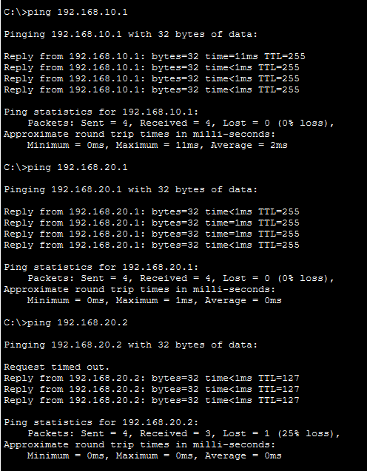
Verification:
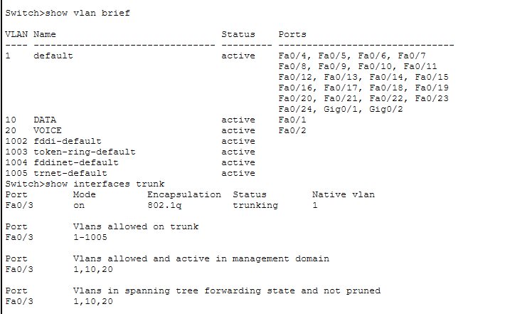

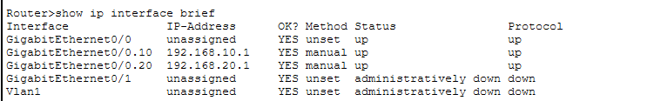
- Implement ACLs to restrict traffic based on source and destination ports. Test rules by simulating legitimate and unauthorized traffic.
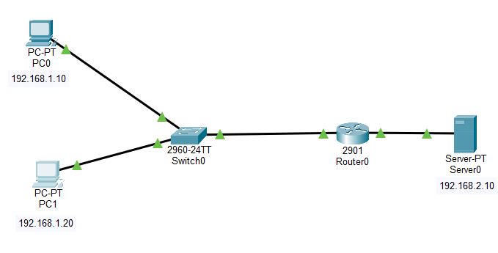
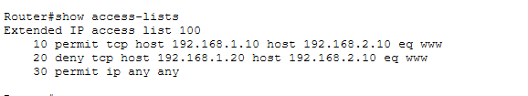
Allows PC0:
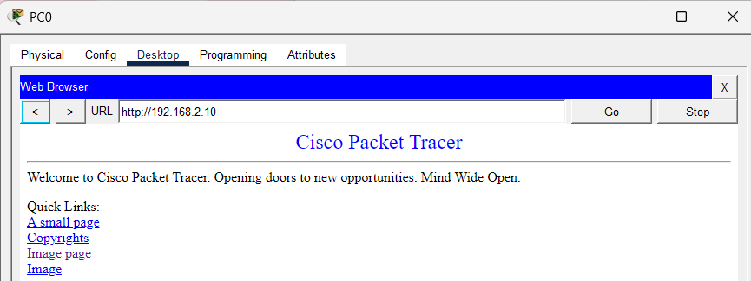

Blocks PC1:
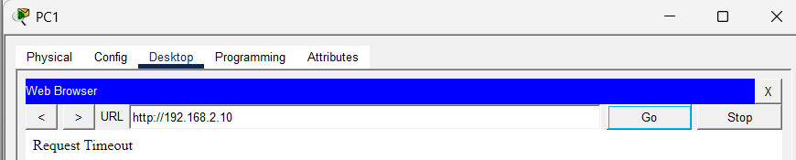
Router CLI:
enable
configure terminal

no access-list 100

access-list 100 permit tcp host 192.168.1.10 host 192.168.2.10 eq 80
access-list 100 deny tcp host 192.168.1.20 host 192.168.2.10 eq 80
access-list 100 permit ip any any

Extended ACL was implemented to restrict HTTP traffic based on source IP and destination port. Authorized traffic was permitted and unauthorized traffic was denied successfully.
Here HTTP is blocked from one PC but allowed from another PC
- Create an extended ACL to block specific applications, such as HTTP or FTP traffic.
Test the ACL rules by attempting to access blocked services.


Router CLI:
enable
configure terminal
access-list 110 deny tcp any host 192.168.2.10 eq 80 for http or 21 for ftp
access-list 110 permit ip any any
interface g0/0
ip access-group 110 in

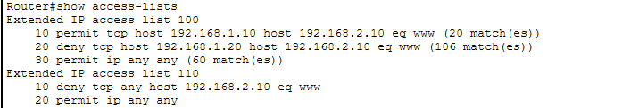

HTTP blocked in PC0:
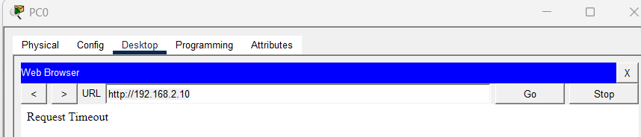

HTTP blocked in PC1:
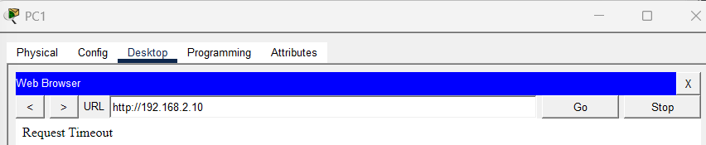

Ping allowed in PC0:
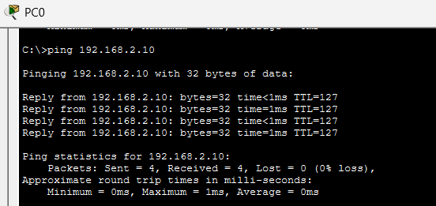
Ping allowed in PC1:
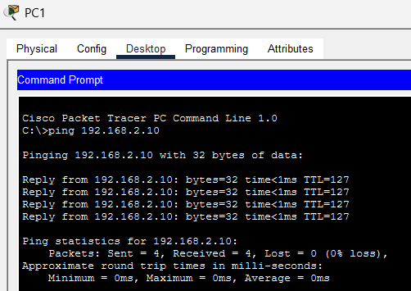

Here a specific application is blocked, either it’s PC0 or PC1.
HTTP is blocked from both the PC’s.

- Configure a standard Access Control List (ACL) on a router to permit traffic from a specific IP range.
Test connectivity to verify the ACL is working as intended.
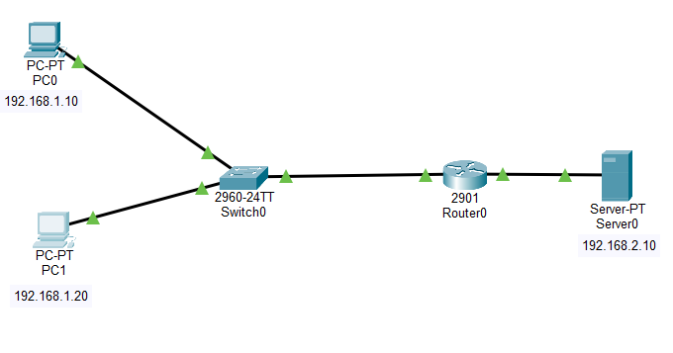Router CLI:
enable
configure terminal
access-list 10 permit 192.168.1.10 0.0.0.0
access-list 10 deny any
enable
configure terminal
access-list 10 permit 192.168.1.10 0.0.0.0
access-list 10 deny any

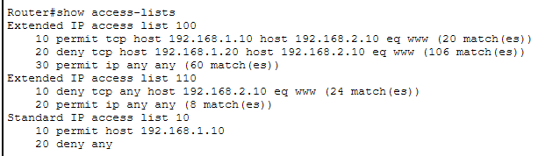

PC0 allowed to ping :
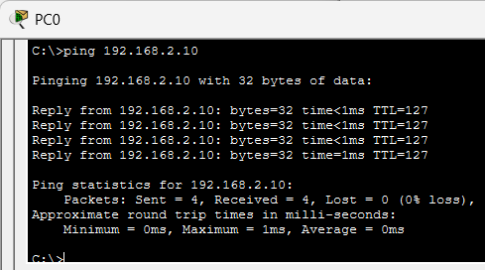

PC1 blocked to ping:
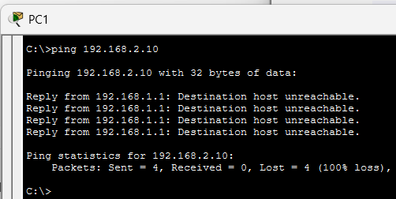

Here a particular IP Source (here it is PC0 ) is blocked, it means if we ping or if we open http from that specific PC it won’t work.
- Try Static NAT, Dynamic NAT and PAT to translate IPs.
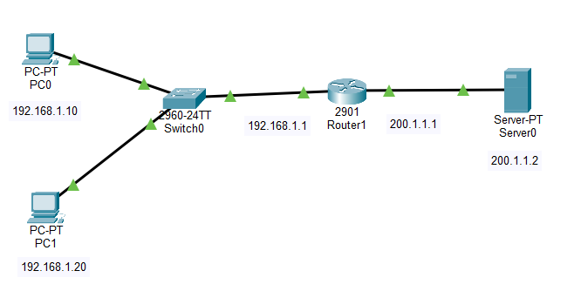
Router CLI common for static nat, dynamic nat and pat:
enable
configure terminal
interface g0/0
ip address 192.168.1.1 255.255.255.0
ip nat inside
no shutdown
interface g0/1
ip address 200.1.1.1 255.255.255.0
ip nat outside
no shutdown
Static NAT:
ip nat inside source static 192.168.1.10 200.1.1.10
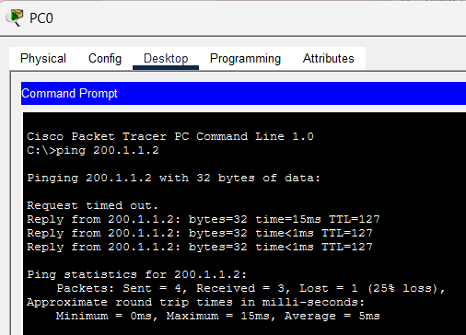

After pinging check NAT table:
show ip nat translations
Now removing static NAT:
no ip nat inside source static 192.168.1.10 200.1.1.10
Dynamic NAT:
access-list 1 permit 192.168.1.0 0.0.0.255
ip nat pool NATPOOL 200.1.1.20 200.1.1.30 netmask 255.255.255.0
ip nat inside source list 1 pool NATPOOL
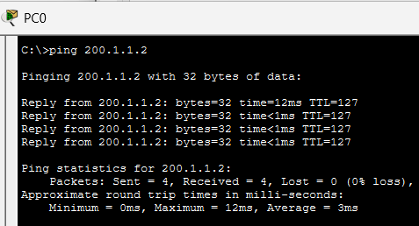
After pinging check NAT table:
show ip nat translations
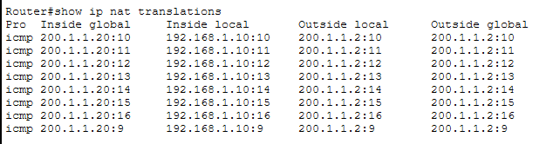

Removing Dynamic NAT:
no ip nat inside source list 1 pool NATPOOL
PAT:
ip nat inside source list 1 interface g0/1 overload
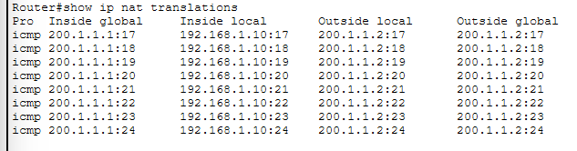
- Download iperf in laptop/phone and make sure they are in same network.
Try different iperf commands with:
tcp
udp
bidirectional
reverse
multicast
parallel options
Analyze the bandwidth and rate of transmission, delay, jitter etc.
PHONE: SERVER
LAP: CLIENT

TCP:
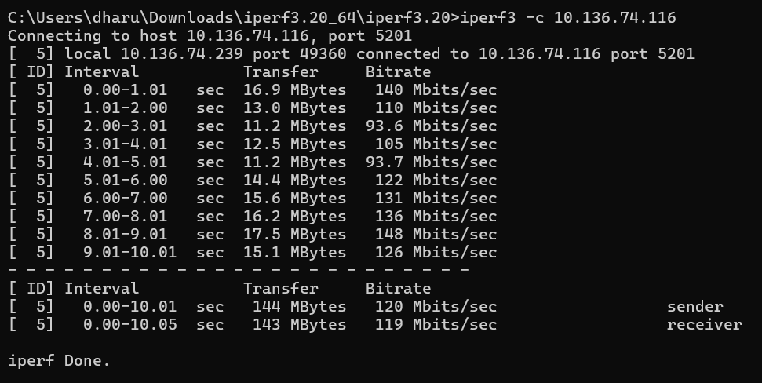
UDP:
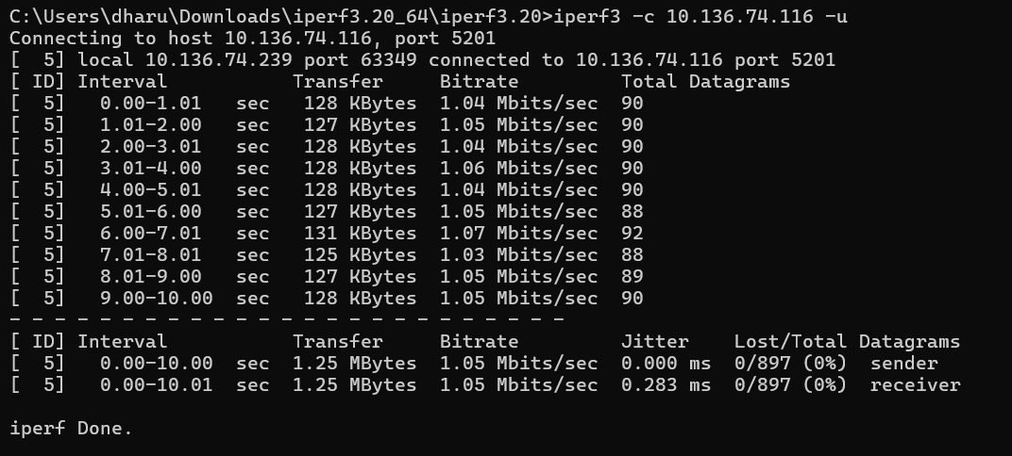
REVERSE TEST:
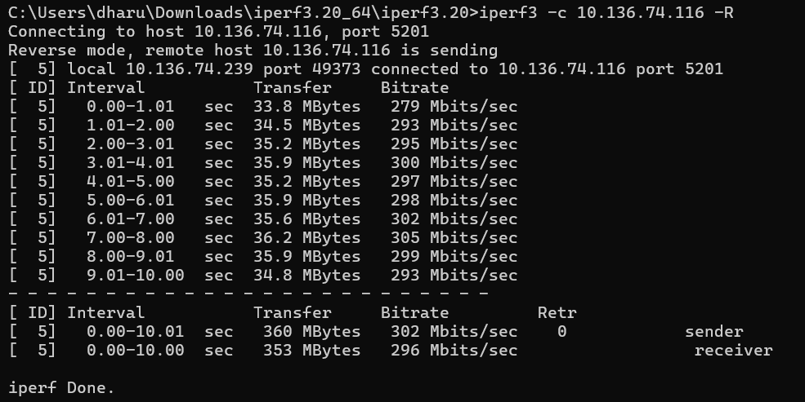
BIDIRECTIONAL:
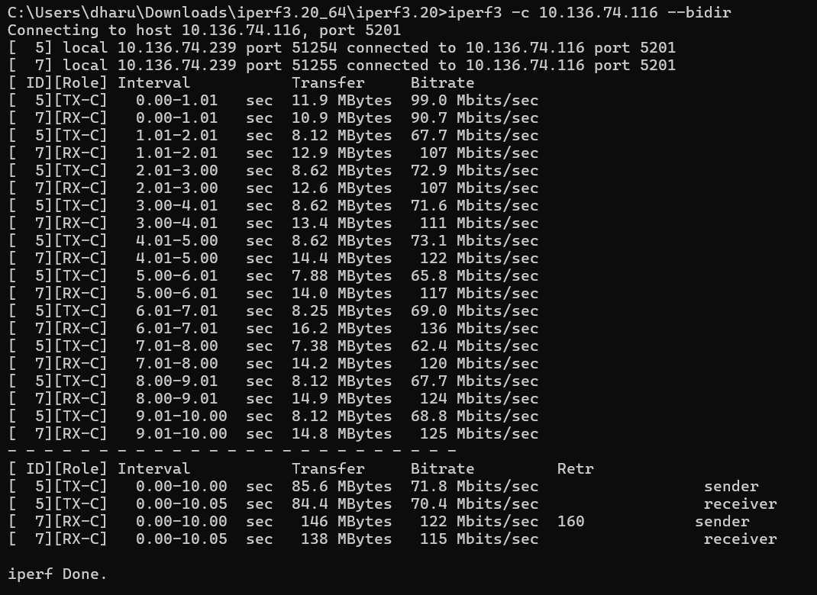
PARALLEL STREAM:
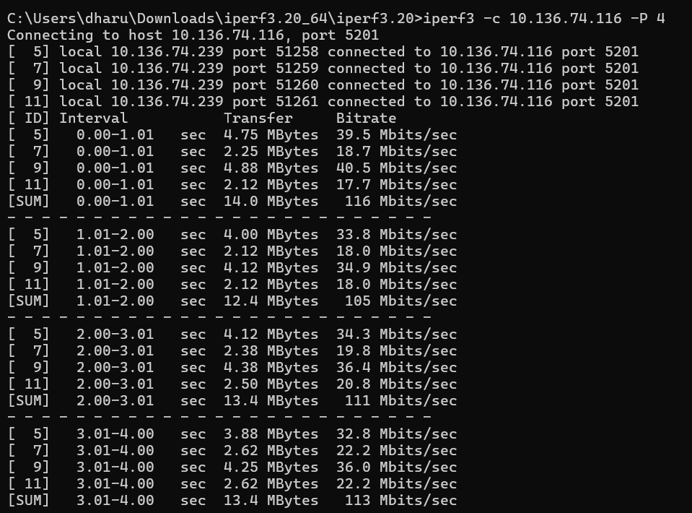
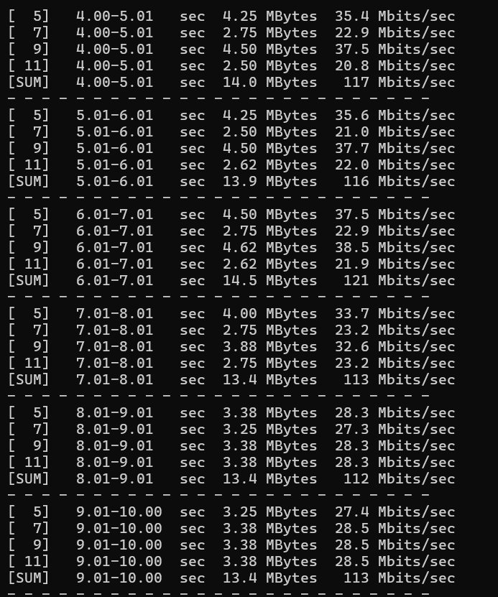
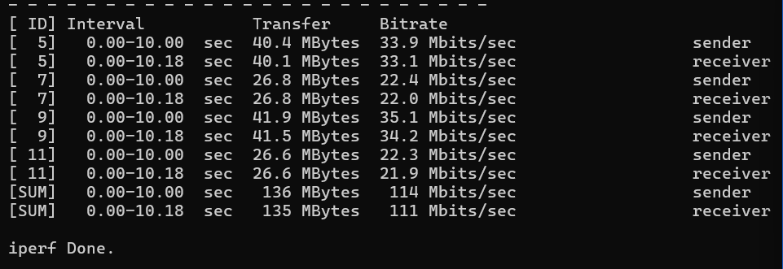

UDP BANDWIDTH:
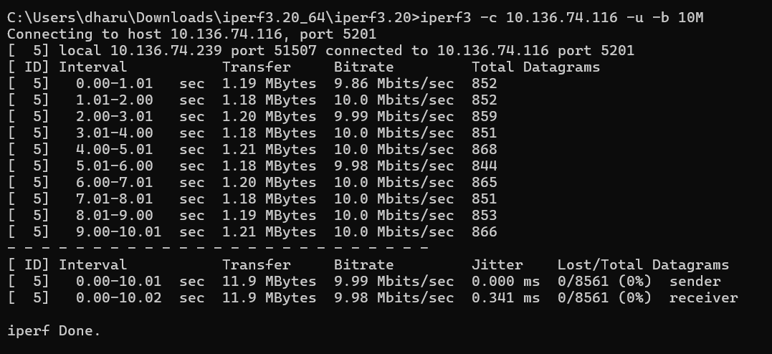

Test Type | Transfer | Bandwidth / Bitrate | Jitter | Packet Loss | Observation
TCP | 144 MB | ~120 Mbps | N/A | 0% | Reliable data transfer with high throughput
UDP | 1.25 MB | ~1.05 Mbps | 0.283 ms | 0% | Low jitter, suitable for real-time traffic
Reverse | 360 MB | ~300 Mbps | N/A | 0% | Download speed higher than upload
Bidirectional | 85–146 MB | ~70–120 Mbps | N/A | Some retransmissions | Upload and download simultaneously share bandwidth
Parallel Streams | 135 MB | ~110 Mbps | N/A | 0% | Multiple streams improve throughput
UDP Bandwidth (10M) | 11.9 MB | ~10 Mbps | 0.341 ms | 0% | Stable transmission at limited bandwidth

